Open the application in Chrome

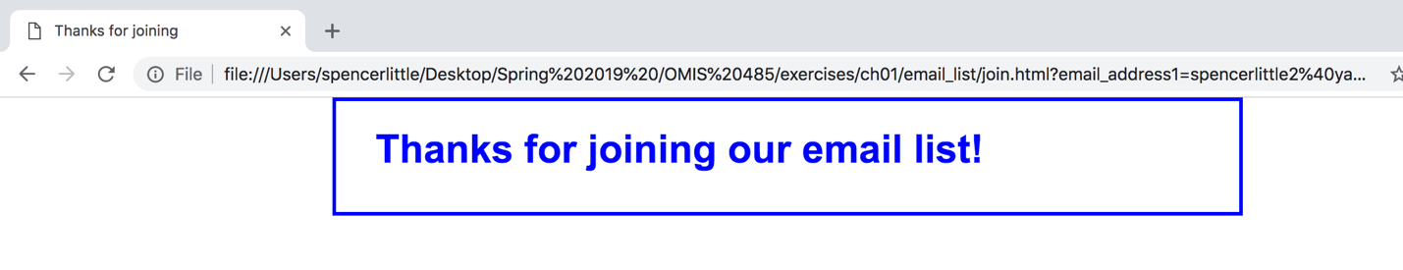

Preview the developer tools

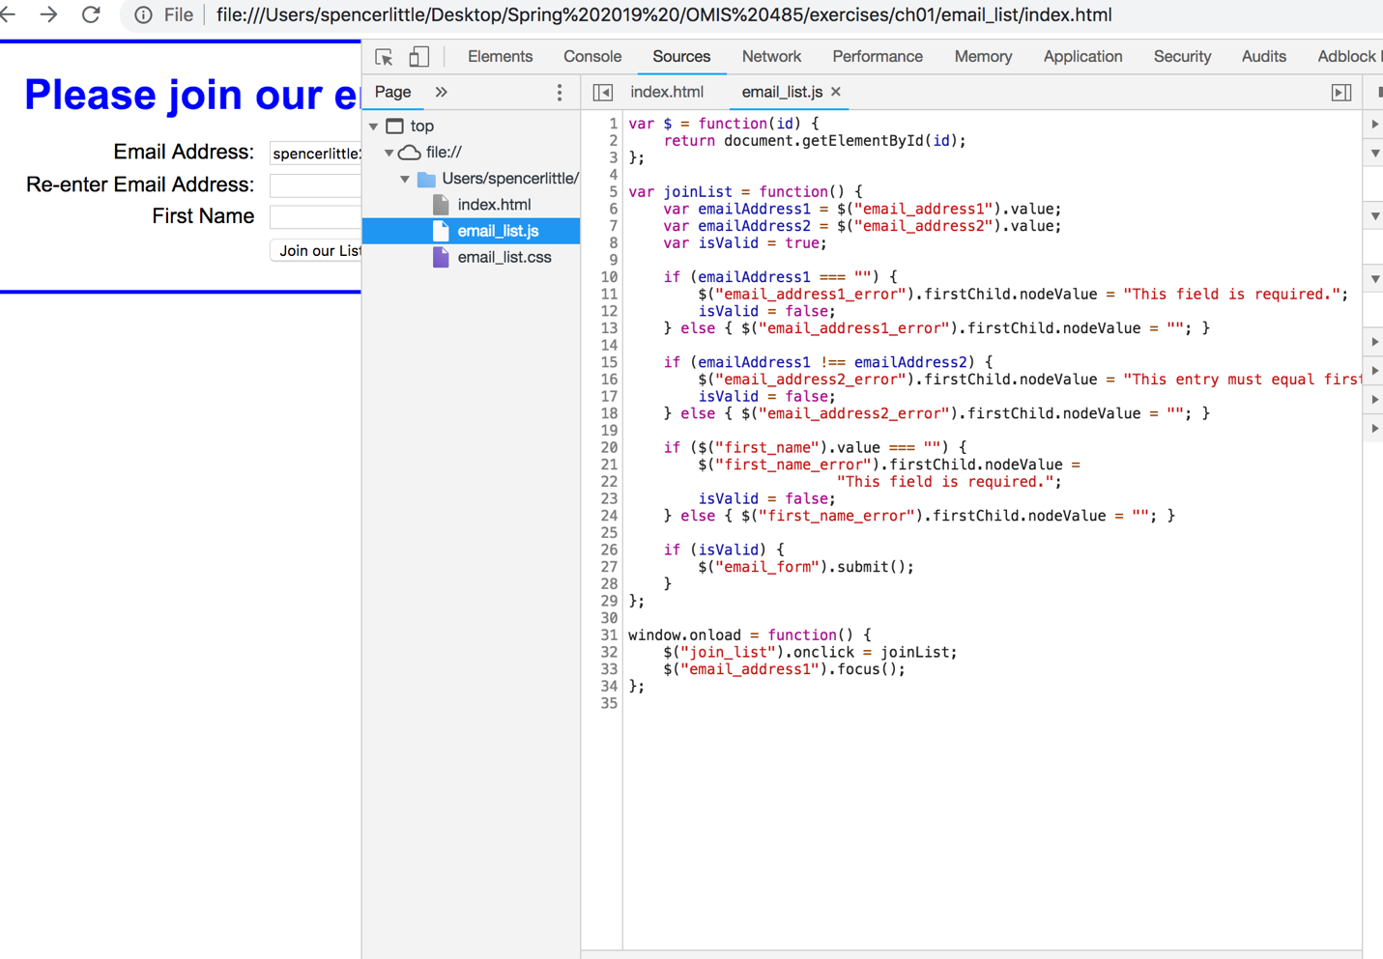

Run the FAQs application of chapter 6

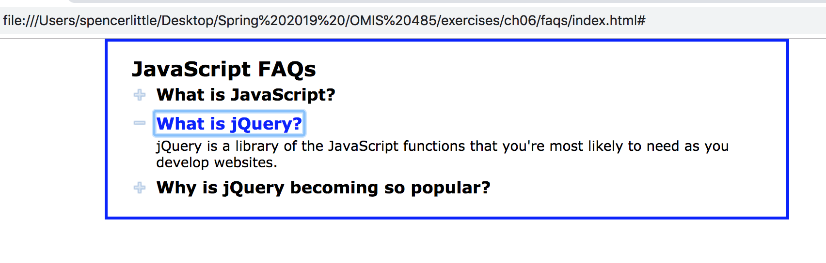

Run the image Swap application of chapter 7

